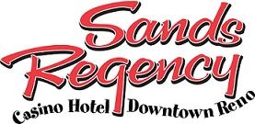

Special Tournament Rates 2019
Tournament Date Code Rate
Summer Blast August 2-4 NVASA080219 $75
USA Softball August 9-11 NVASA080919 $75
Summer Slammer August 16-18 NVASA081619 $75
Native American Championship Sept 5-8 NVASA090619 $75
Toys 4 Tots Sept 20-22 NVASA092019 $75
Breast Cancer Sept 27-29 NVASA092719 $119
Blood N Guts Oct 11-13 NVASA101119 $75
Blood N Guts Oct 18-20 NVASA101819 $75
Blood N Guts Oct 25-27 NVASA102519 $75
This and That Nov 1-3 NVASA110119 $75
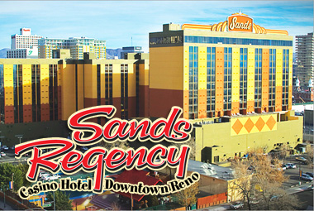
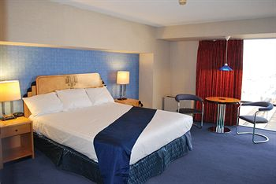
Call Lisa Miolini for other dates 775-544-3958

